H.T No
Regulations:
A19

Sreenidhi Institute of Science and Technology
(An Autonomous Institution)
Code No: 7Z338 Date: 09-Aug-2023 (FN)

MBA II-Year I- Semester External Examination, July/August-2023 (Supplementary)
QUANTITATIVE APTITUDE AND LOGICAL REASONING

Time: 3 Hours Max.Marks:70

Note: a) No additional answer sheets will be provided.
b) All sub-parts of a question must be answered at one place only, otherwise it will not be valued.
c) Missing data can be assumed suitably.
Bloom's Cognitive Levels of Learning (BCLL)

Remember | L1 | Apply | L3 | Evaluate | L5
Understand | L2 | Analyze | L4 | Create | L6

Part - A Max.Marks:20

Answer all QUESTIONS.

 |  | BCLL | CO(s) | Marks
1 | In a certain code ROAD is written as URDG. How is SWAN written in that code? | L2 | CO1 | [2M]
2 | 120,99,80,63,48? | L1 | CO2 | [2M]
3 | What percent of a day is 3 hours? | L2 | CO3 | [2M]
4 | If (4x²-3y²):(2x²+5y²)=12:19, then x:y is how much? | L2 | CO4 | [2M]
5 | A , B and C can complete a piece of work in 24, 6 and 12 days respectively. In how many days they will complete the work if all work together? | L4 | CO5 | [2M]
6 | Find the surface area of a cuboid which is 14m long, 5m broad and 6m height? | L5 | CO6 | [2M]
7 | Pointing to an old man Ravi said, “His son is my son’s uncle”. How is the old man related to Ravi ? | L2 | CO2 | [2M]
8 | If a radio is purchased for Rs.490 and sold for Rs. 465.50. Find the loss percent? | L5 | CO3 | [2M]
9 | Find the simple interest on Rs. 68,000 at 16% per annum for 9 months? | L3 | CO5 | [2M]
10 | Find the average of first 10 multiples of 7? | L3 | CO6 | [2M]

Part – B Max.Marks:50
ANSWER ANY FIVE QUESTIONS. EACH QUESTION CARRIES 10 MARKS.

 |  |  | BCLL | CO(s) | Marks
11. | a) | In the series AHQ, DJR, GLS, JNT, ?  The next term is? | L3 | CO1 | [5M]
 | b) | Pointing to a lady, a girl said, “She is the only daughter-in-law of the grandmother of my father’s son”. How is the lady related to the girl. | L1 | CO1 | [5M]
12. | a) | Statements: Some ships are boats. All boats are submarines. Some submarines are yatches.  Conclusion:  i) Some yatches are boats.  ii) Some submarines are boats.  iii) Some submarines are ships.  iv) Some yatches are ships  Which statement/s follow? | L5 | CO2 | [5M]
 | b) | Find the angle between the hands of the clock when the time is 10:30AM. | L4 | CO2 | [5M]
13. | a) | In finding the HCF of two numbers, the last divisor is 52 and the respective quotients, starting from the first are 2, 11 and 7. The numbers are. | L1 | CO3 | [5M]
 | b) | If 50 % of (x-y) = 30% of (x+y), then what percent of x i y. | L4 | CO3 | [5M]
14. | a) | Salaries of Ravi and Sumit are in the ratio 2:3. If the salary of each is increased by Rs. 4000, the new ratio becomes 40:57. What is Sumit's salary? | L4 | CO4 | [5M]
 | b) | i) If class A has 9 boys and 17 girls and class B has 7 boys and 19 girls. Which class has a lesser ratio of boys to girls?  ii) Compare the ratios 5:6 and 7:9 and find which ratio is greater. | L4 | CO4 | [5M]
15. | a) | A man took a loan from a bank at the rate of 12 % per annum simple interest. After 3 years he had to pay Rs. 5400 interest only for the period. The principal amount borrowed by him was. | L2 | CO5 | [5M]
 | b) | How long will a boy take to run round a square field of side 35 meters, If he runs at the rate of 9 km/hr? | L3 | CO5 | [5M]
16. |  | The following pie chart shows the amount of subscriptions generated for India Bonds from different categories of investors.  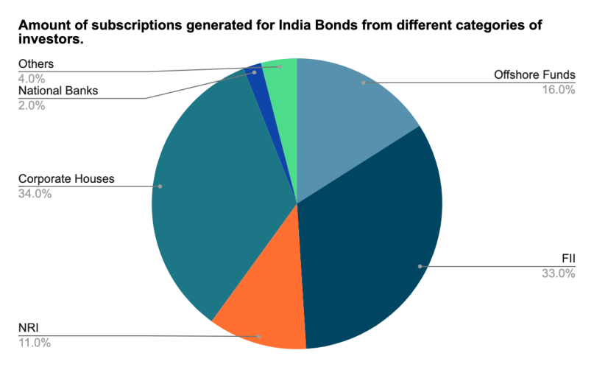  i) In the corporate sector, approximately how many degrees should be there in the central angle ?  ii) If the investment by NRI’s are Rs 4,000 crore, then how much is the investments by corporate houses and FII’s together?  iii) What percentage of the total investment is coming from FII's and NRI's ?  iv) If the total investment other than by FII and corporate houses is Rs 335,000 crore, then how much is the investment by NRI's and Offshore funds (approximately)?  v) If the total investment flows from FII's were to be doubled in the next year and the investment flows from all other sources had remained constant at their existing levels for this year, then what would be the proportion of FII investment in the total investment into India Bonds next year (in US $ millions)? | L5 | CO6 | [10M]
17. | a) | Six lectures are organized during a week, starting from Monday & ending on Sunday. Computer Science is not on Tuesday or Saturday. Psychology is exactly after the Organizational Practices. Statistics is not on Friday & there is a holiday for one day between Statistics & Research Methods. There is not any lecture before Economics (because it is a holiday & Monday is not a holiday).  - Which of the following is the last lecture organized?  - Which lecture will be conducted on Friday?  - How many lectures were organized between Economics & Psychology?  - On which day Computer Science was organized? | L5 | CO1 | [4M]
 | b) | Two horsemen start from different localities 36 kms apart, towards each other. If the two are traveling at uniform speeds of 15 km and 12 km, the time after which they will meet is. | L4 | CO5 | [3M]
 | c) | grocer has a sale of Rs. 6435, Rs. 6927, Rs. 6855, Rs. 7230 and Rs. 6562 for 5 consecutive months. How much sale must he have in the sixth month so that he gets an average sale of Rs. 6500. | L4 | CO3 | [3M]
-- 00 -- 00 –

